Department of Computer Science & Engineering
Microprocessor & Computer Architecture Lab

Lab 5 Programs
UE24CS251B

Q1. Write a program in ARM7TDMI-ISA to transfer a block of 16 words stored at memory location X to memory location Y using Load Multiple and Store Multiple instructions. The rate of transfer is 24 bytes

LDR R0, =X
LDR R1, =Y
MOV R2, #2
LOOP:
LDMIA R0!, {R3-R8}
STMIA R1!, {R3-R8}
SUBS R2, R2, #1
BNE LOOP
LDMIA R0!, {R3-R6}
STMIA R1!, {R3-R6}
SWI 0x11
X: .word 1,2,3,4,5,6,7,8,9,10,11,12,13,14,15,16
Y: .space 64

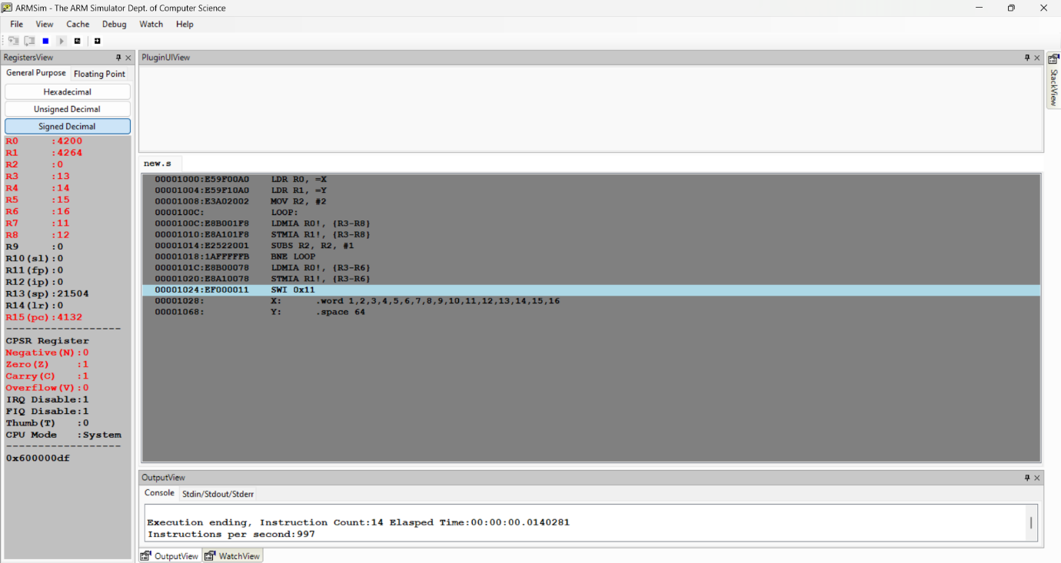

Q2. Write a program to perform 3X3 matrix addition.

LDR R0, =M1
LDR R1, =M2
LDR R2, =RES
MOV R3, #9
ADDER:
LDR R4, [R0], #4
LDR R5, [R1], #4
ADD R6, R4, R5
STR R6, [R2], #4
SUBS R3, R3, #1
BNE ADDER
SWI 0x11
M1: .word 1,2,3,4,5,6,7,8,9
M2: .word 1,1,1,1,1,1,1,1,1
RES: .space 36

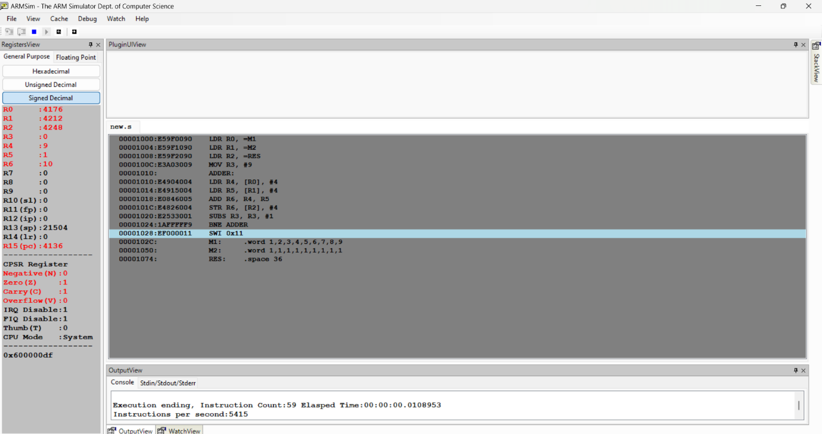

Q3. Write a program to find the length of a string.

LDR R0, =STR
MOV R1, #0
COUNT:
LDRB R2, [R0], #1
CMP R2, #0
BEQ EXIT
ADD R1, R1, #1
B COUNT
EXIT:
SWI 0x11
STR: .ascii "PES UNIVERSITY"
.byte 0

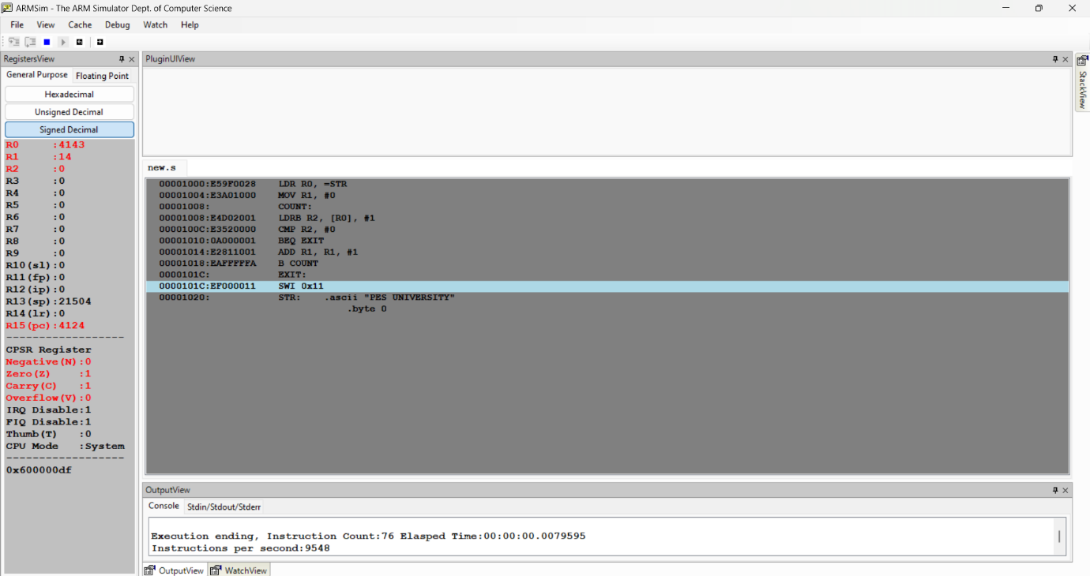

Q4. Write a program to copy a string from one location to another location.

LDR R0, =SRC
LDR R1, =DST
COPY:
LDRB R2, [R0], #1
STRB R2, [R1], #1
CMP R2, #0
BNE COPY
SWI 0x11
SRC: .ascii "OS LAB"
.byte 0
DST: .space 10

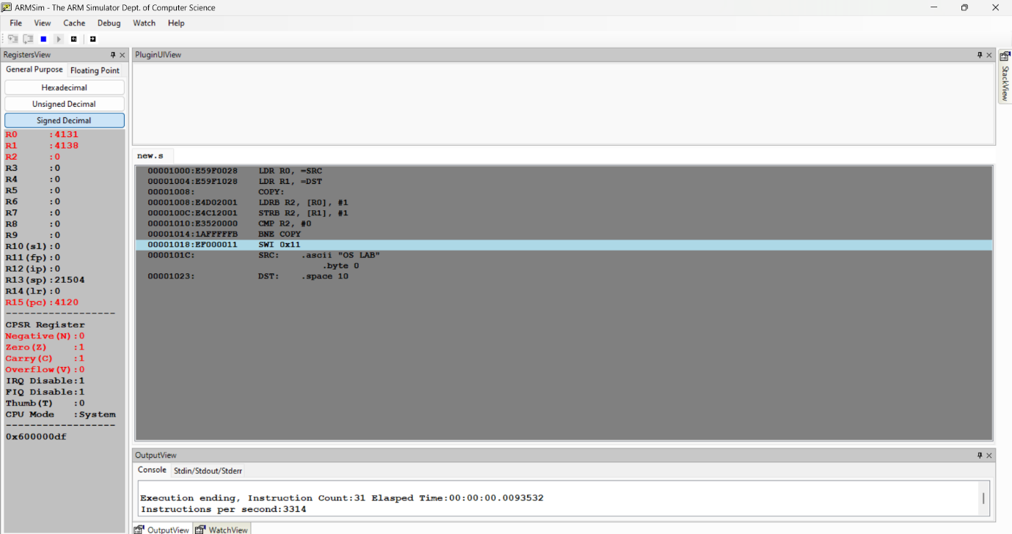

Q5. Write an ALP to find how many times the given character is present in a string.

LDR R0, =S
MOV R1, #'a'
MOV R2, #0
SCAN:
LDRB R3, [R0], #1
CMP R3, #0
BEQ END
CMP R3, R1
ADDEQ R2, R2, #1
B SCAN
END:
SWI 0x11
S: .ascii "banana"
.byte 0



